Response.Write("<script language=javascript>alert('Unable to approve.\\n Processed.');</script>");

**Create a message box**

When a user interacts with your page, an event occurs. Nearly every JavaScript object is event driven

<input type="button" value="Click me" onClick="alertUser( ) ">

alert( "Welcome" )

**Capture user input**

alert( " Welcome! " + prompt("Enter your name ", "") )

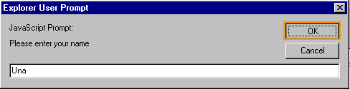

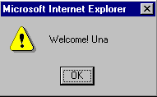

Var_Value = prompt(“Enter value”)

**ALERTS EN C#**

Page.ClientScript.RegisterStartupScript(GetType(), "msgbox", "alert('FiveDotssfully');", true);

Pero si se da dentro de un UpdatePanel

ScriptManager.RegisterStartupScript(this, GetType(), "alert", "alert('Ouve algum problema n');", true);

// When click button call function

Button1.Attributes.Add("onclick","**PopWindow**();");

// When MouseDown on control data1

data1.Attributes.Add("onmousedown", "PopWindow();");